1. Run a map only job on the word count program using static configurations.

Here we need to count the words using map only i.e. no reducer has to used. So we are implementing cleanup method in the mapper and the word count is performed.

The mapper method is invoked for all the line of the dataset and the cleanup method is evoked only once and the word count is done. The screen shots are attached below:

Driver Class:

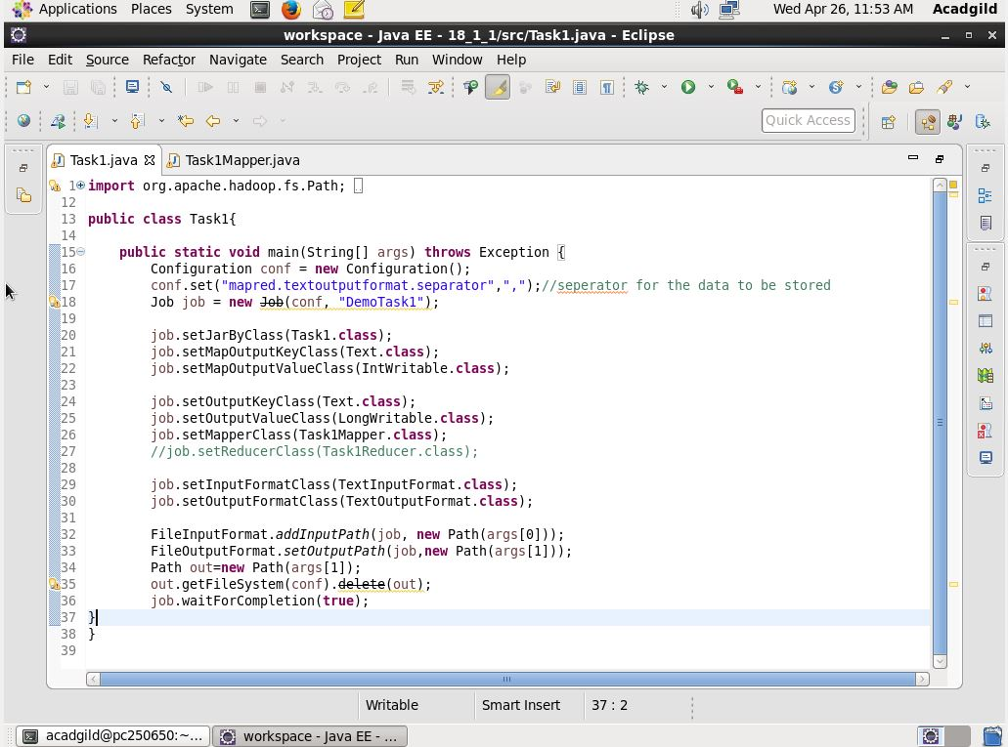

Mapper Class: for map only

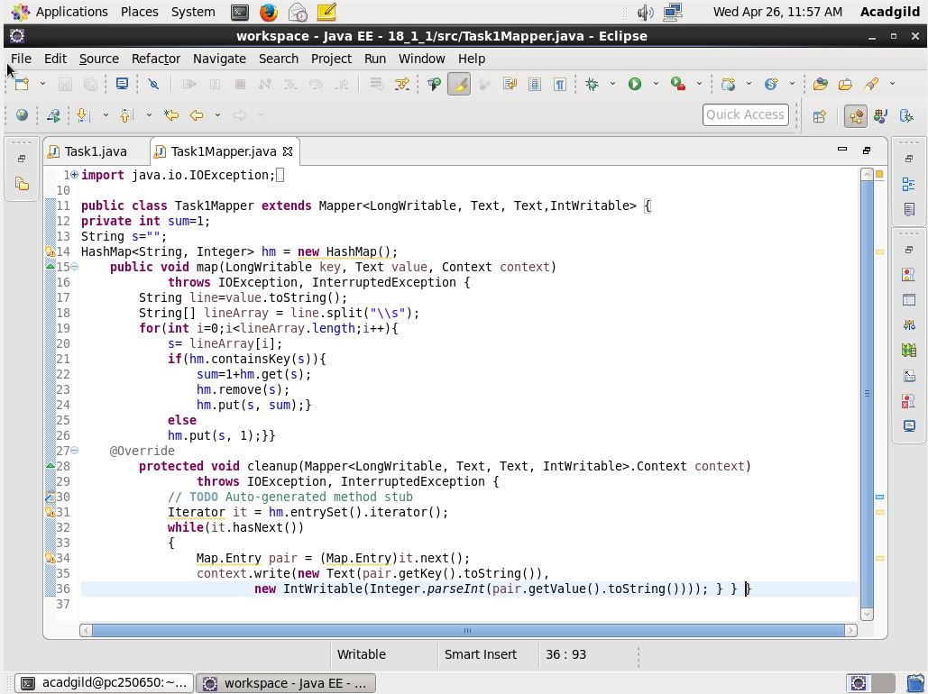

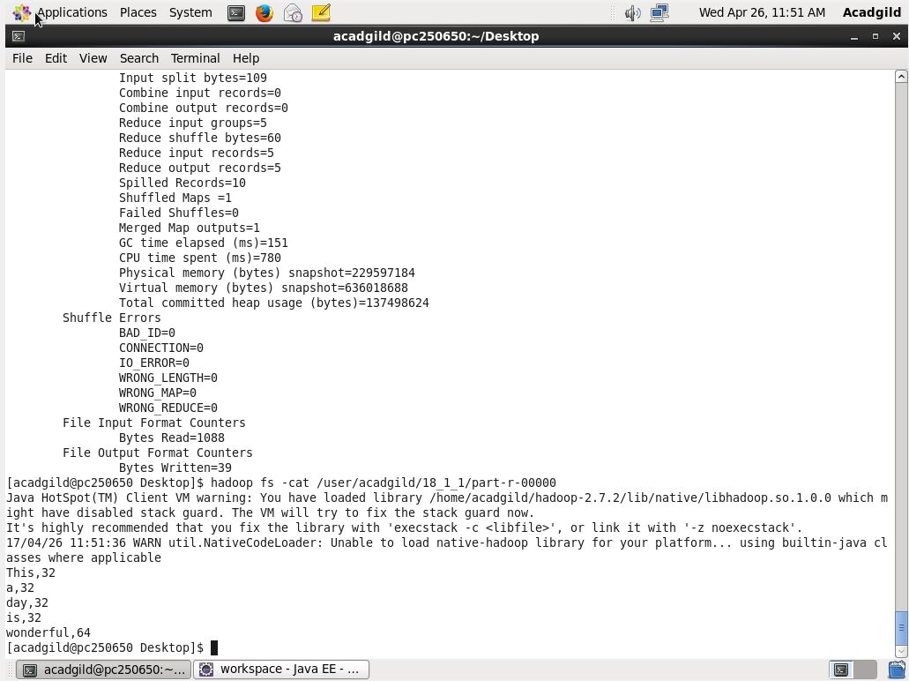

Answer to the executed code.

1. Run the mapreduce word count program and set the number of reducers to 2 using static configurations.

Here we are setting the number of reducers to 2. For that we use the command

Job.setnumReduceTask(2);

We can set the number of reducers according to our need. the below code shows the demo of the required code using an example of word count.

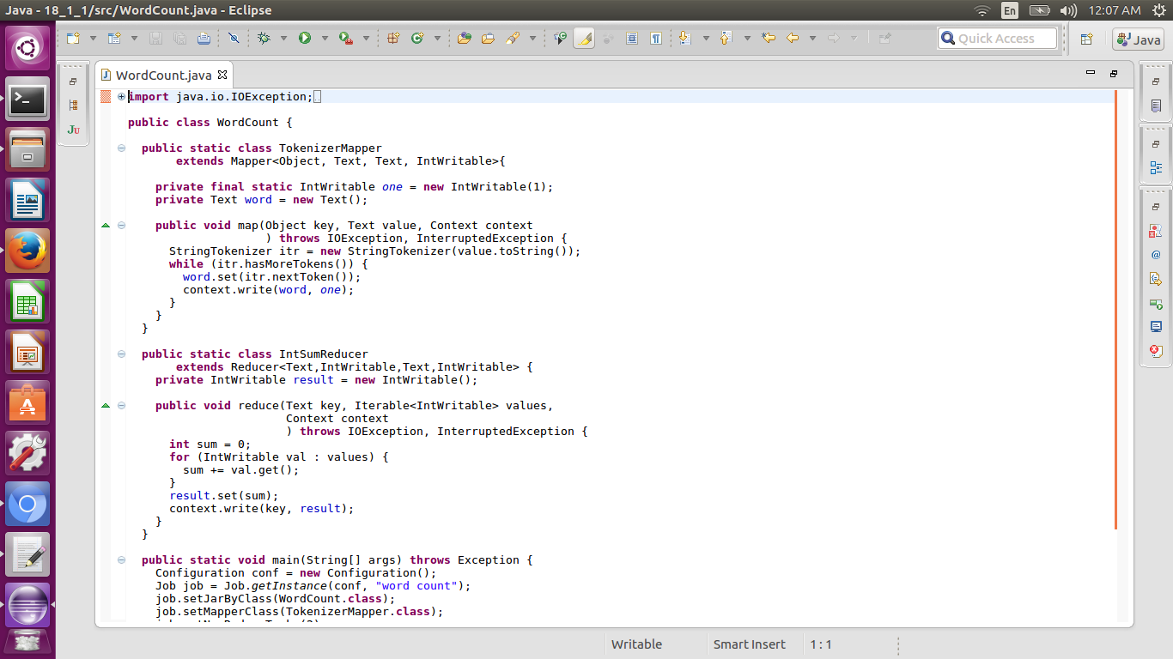

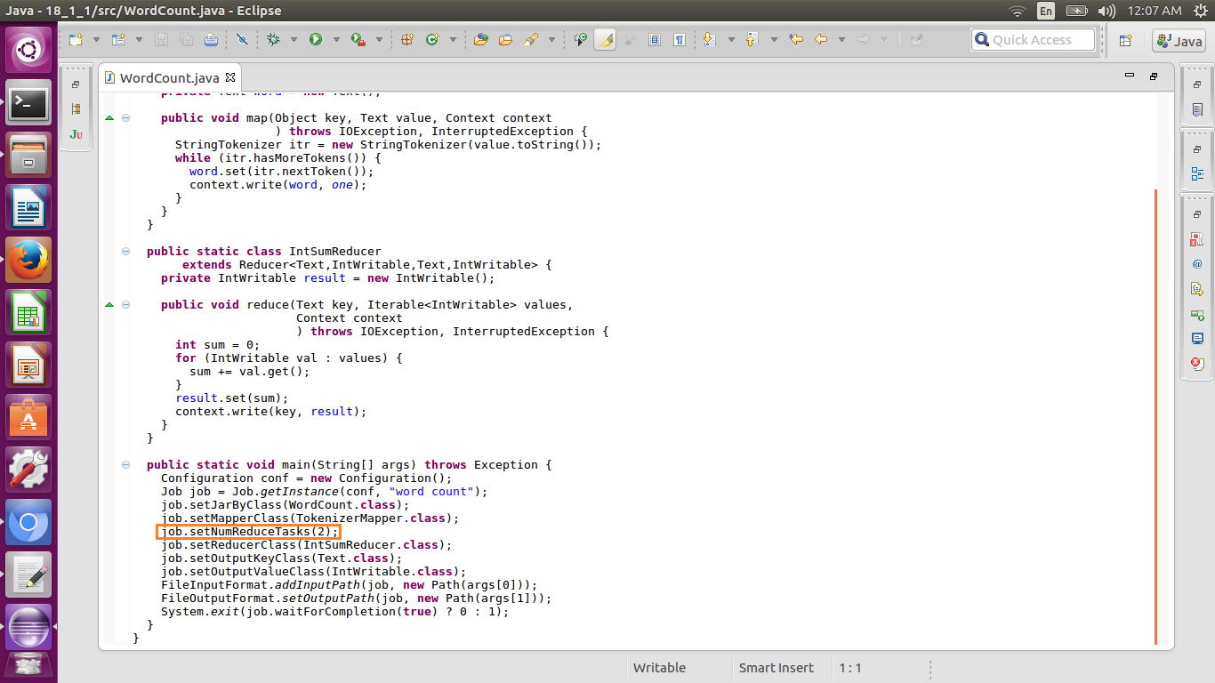

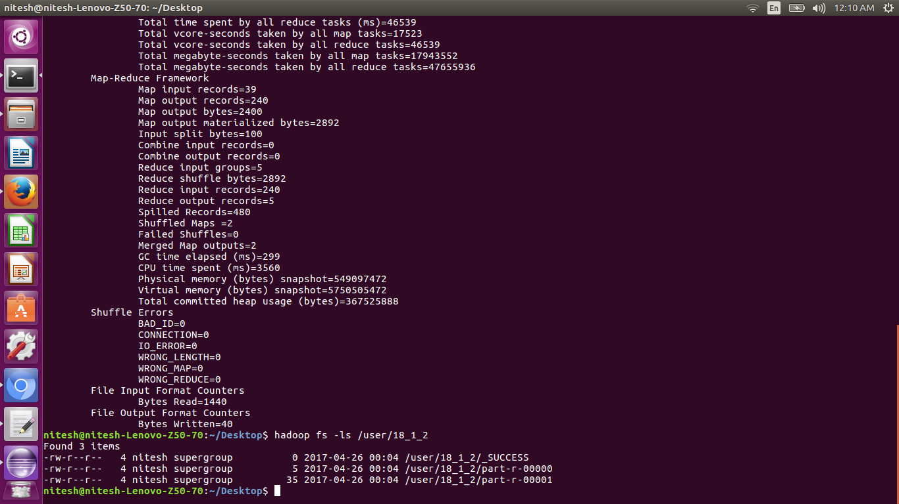

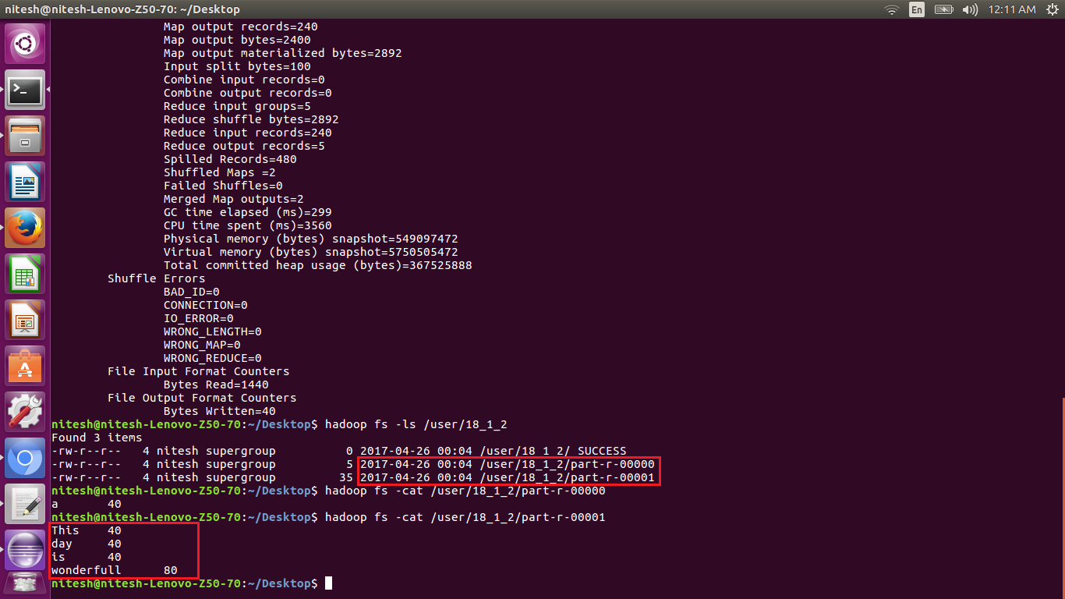

There the first block shows the output files generated by the 2 reducers and the output

a 40

is the output of the first reducer

where the second blocl is the output of the second reducers.

The keys are segregated according to the hashcode.